
SWT 12041 – Practical for Web systems and Technologies
Faculty of Technology
South Eastern University of Sri Lanka
LAB SHEET 01
Reg. Number: SEU/IS/20/ICT/084
Academic Year :2020/2021
Date: 2023.01.25
Practical No : 01

Title: Introduction to HTML.
Aims:
- Getting an introduction to HTML basic.
- Getting practice to work with basic HTML tags.
- Getting practice to execute HTML file.

Task:
Basic Tags
- HTML tag
- Head tag
- Title tag
- Body tag
- Heading tag
- Paragraph tag
- Div tag
- Image tag
- Underline
- Subscript and superscript tag
- Italic
- Bold
- Pre tag
- Marquee tag

- Link tag
- Table tag
- Order lists

Activites:

- Write the basic structure of the web document.
<html>
<head>
<title>My Frist Web Pagh</title>

</head>
<body>
Welcome
</body>

</html>

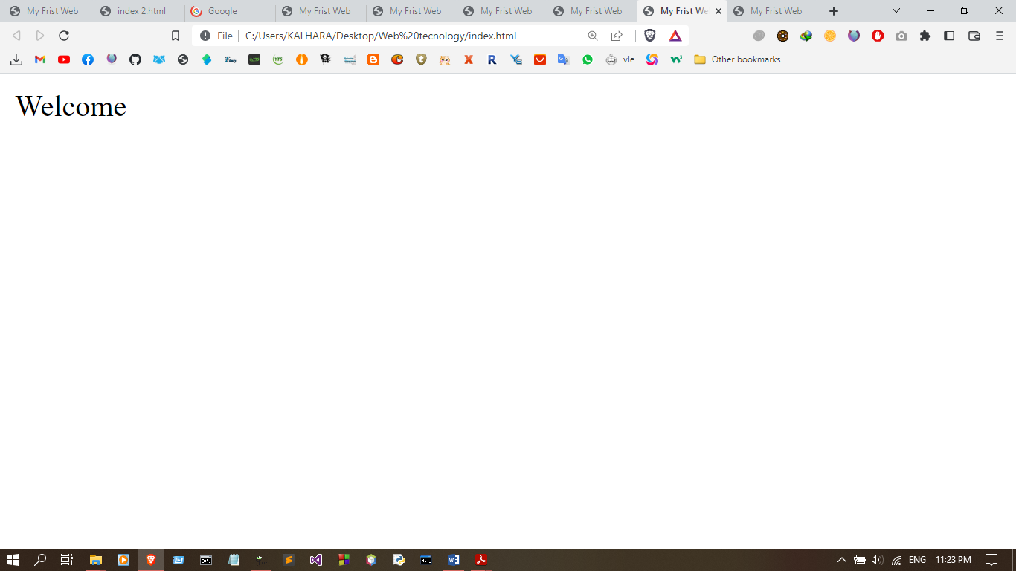
Output:

2. Print the following using paragraph tag
“Video provides a powerful way to help you prove your point. When you click Online Video, you can paste in the embed code for the video you want to add. You can also type a keyword to search online for the video that best fits your document. To make your document look professionally produced, Word provides header, footer, cover page, and text box designs that complement each other.”

<html>
<head>
<titleMy Frist Web </title>
</head>
<body>
<p>
“Video provides a powerful way to help you prove your point. When you click Online Video, you can paste in the embed code for the video you want to add. You can also type a keyword to search online for the video that best fits your document. To make your document look professionally produced, Word provides header, footer, cover page, and text box designs that complement each other.”
</p>
</body>
</html>

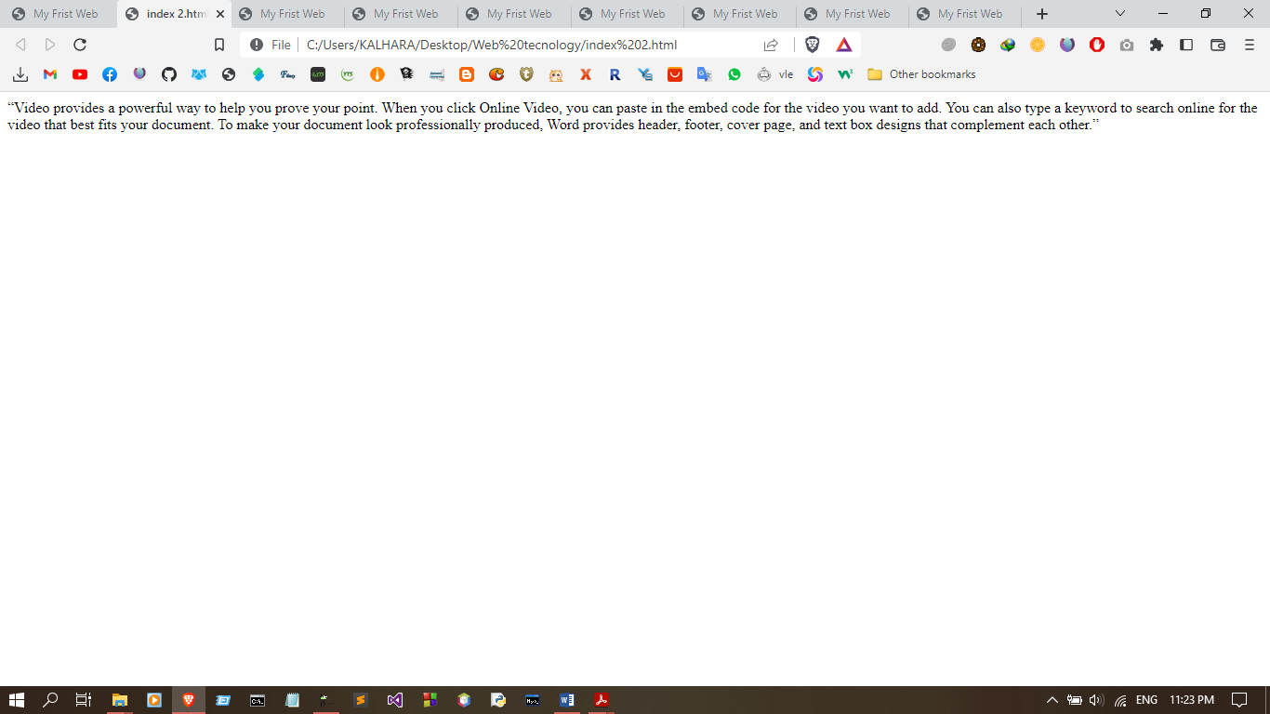
Output:

03.Print the following output using heading tags
This is heading 1
This is heading 2
This is heading 3
This is heading 4
This is heading 5
This is heading 6

<html>
<head>
<title>My Frist Web </title>

</head>
<body>
<h1>This is heading 1</h1>
<h2>This is heading 2</h2>
<h3>This is heading 3</h3>
<h4>This is heading 4</h4>
<h5>This is heading 5</h5>
<h6>This is heading 6</h6>
</body>

</html>
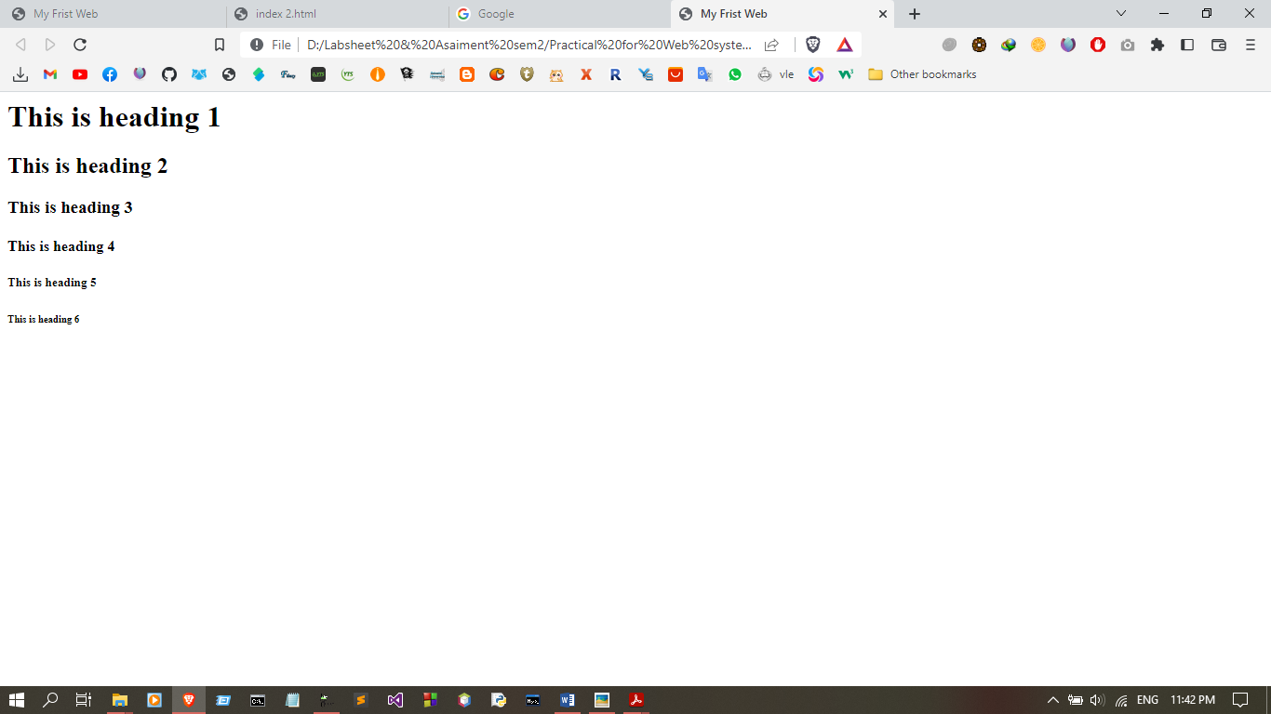
Output:

4. Write a code to link a word with the address of http://www.google.com and the web page should be opened in the same browser tab.

<html>
<head>
<title>My Frist Web </title>

</head>
<body>
<a href="https://www.google.com/">Link</a>
</body>

</html>

Output:
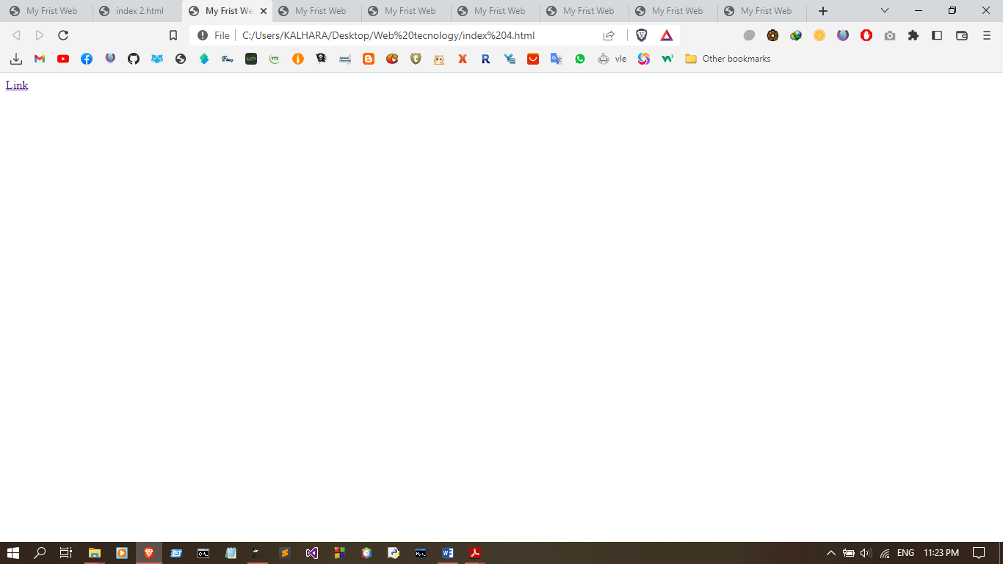

5. Write a code to insert an image using <img> tag and set the additional attributes to the image (Ex: height, width, src, and alt).

<html>
<head>
<title>My Frist Web </title>

</head>
<body>
<img src="img/img1.jpg" alt="Cat Pictures" width="500px" hight="500px" >
</body>

</html>

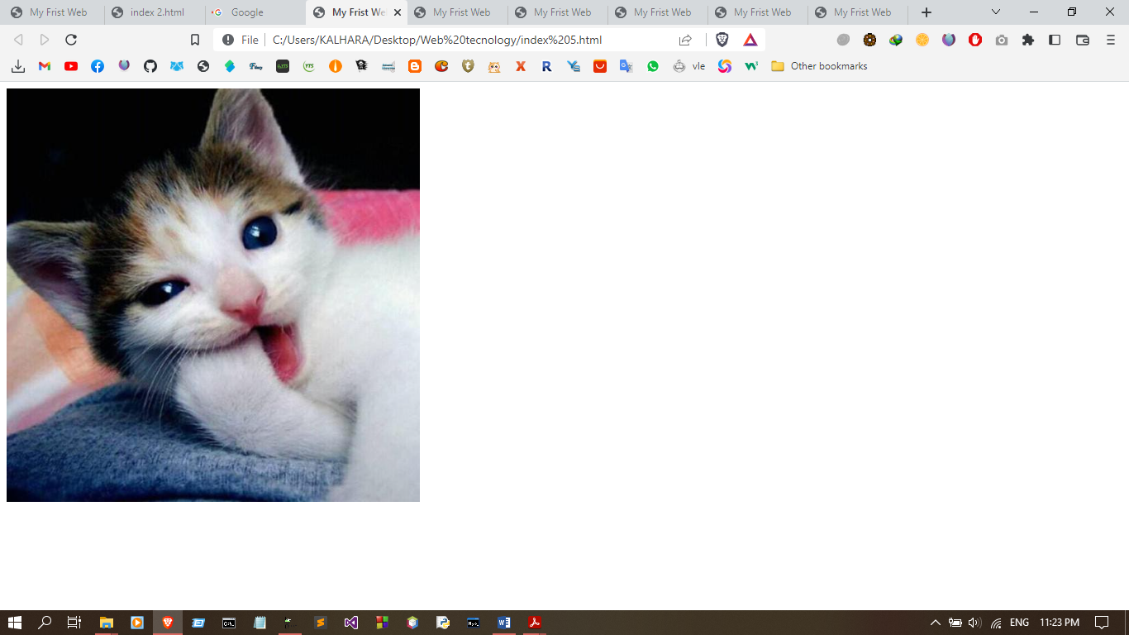
Output:

6. Modify your code of Question 5 to link that image with the address of http://www.google.com.
<html>
<head>
<title>My Frist Web </title>

</head>
<body>
<a href="https://www.google.com/"><img src="img/img1.jpg" alt="Cat Pictures" width="500px" hight="500px" ></a>
</body>

</html>

Output :



7. Get the following output using appropriate tags

a.DO a deer, a female deer
RAY a drop of golden sun
ME a name, I call myself
FAR a long long way to run
SO a needle pulling thread
LA a note to follow so
(Hint: Don’t use <br/> or <p> tag)

  - b. This is H2O and X2
  - c. This is Bold
  - d. My favorite food is cake ice cream
  - e. My favorite color is Green
  - f. Peacock is a bird
- <html>
- <head>
- <title>My Frist Web </title>

- </head>
- <body>
- <div>
- DO a deer, a female deer
- </div>
- <div>
- RAY a drop of golden sun
- </div>
- ME a name, I call myself
- <div>
- FAR a long long way to run
- </div>
- SO a needle pulling thread
- <div>
- LA a note to follow so
- </div>
- <br>
- This is H<sub>2</sub>O and X<sup>2</sup>
    - <br>
- This is <b>Bold</b>
- <br>
- My favorite food is <del>cake</del> ice cream
- <br>
- My favorite color is <u>Green</u>
- <br>
- Peacock is a <mark>bird</mark>
- </body>
- </html>
Output:
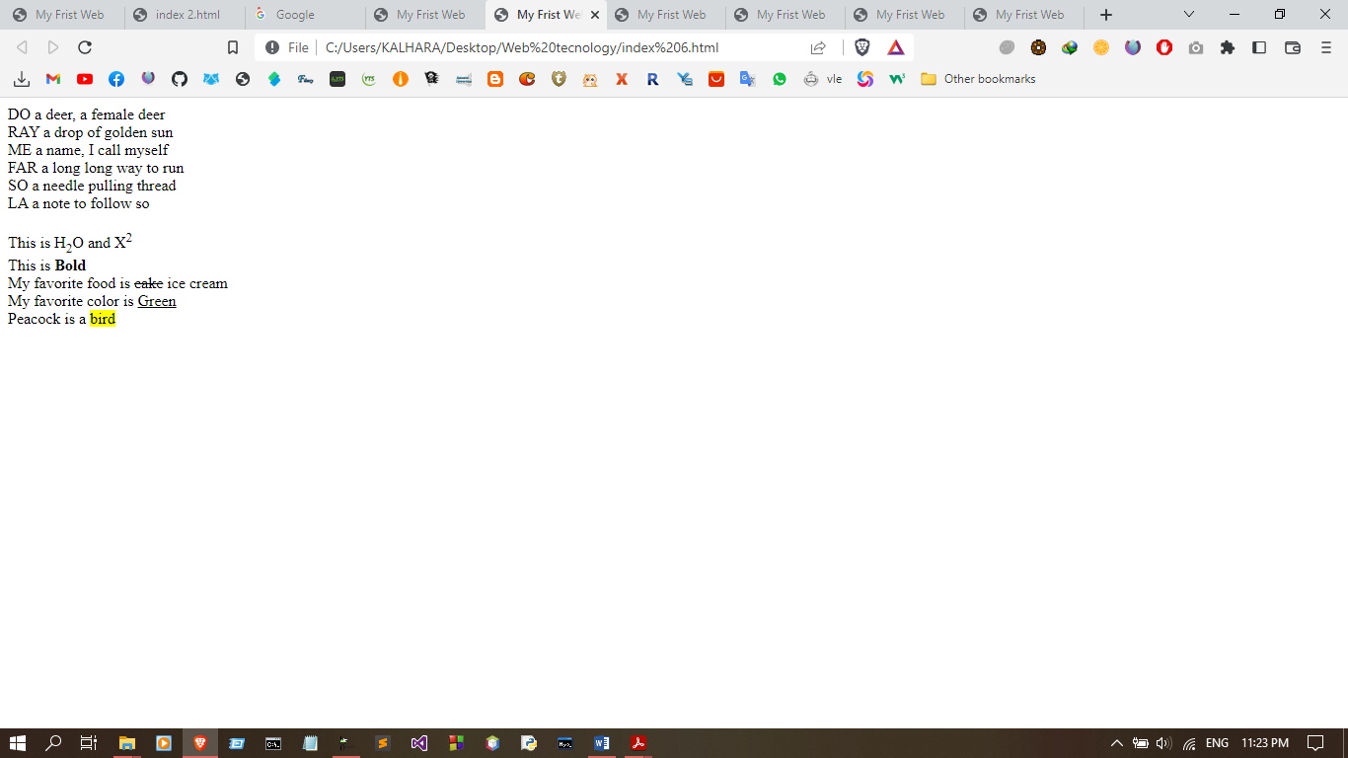

8. Write a code to get the following output (the title of the paragraph should be displayed when you hover the mouse point over the paragraph) using paragraph tag. This is a Paragraph

<html>
<head>
<title>My Frist Web </title>
</head>
<body>
<pre>This is a Paragraph</pre>
</body>
</html>
Output: 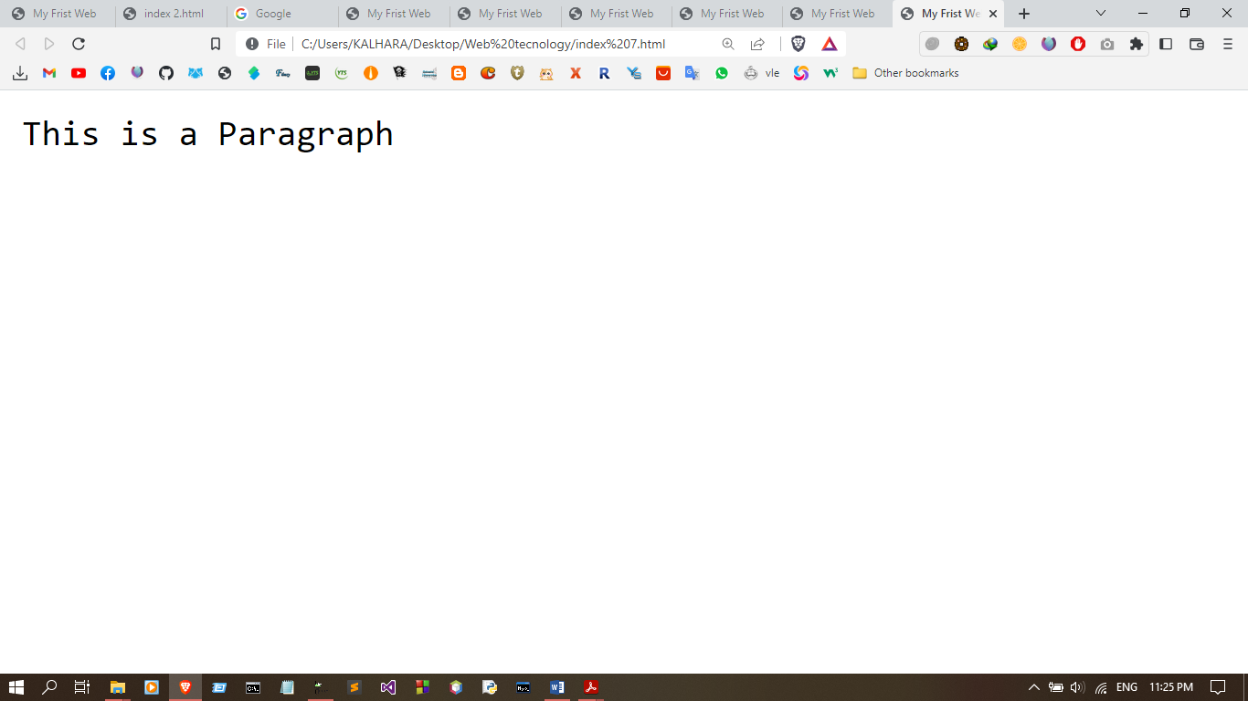

9. Write a code to get the following output of symbols.
- Registered Sign ®
- Copyright Sign ©
- Euro Sign €
- Trademark ™
- Leftwards arrow
- Upwards arrow
- Rightwards arrow
- Downwards arrow

<html>
<head>
<title>My Frist Web </title>

</head>
<body>

<p>Registered Sign &reg;</p>
<p>Copyright Sign &#169;</p>
<p>Euro Sign &euro;</p>
<p>Trademark &#8482;</p>
<p>Leftwards arrow &#8592;</p>
<p>Upwards arrow &#8593;</p>
<p>Rightwards arrow &#8594;</p>
<p>Downwards arrow &#8595;</p>
</body>

</html>

Output:

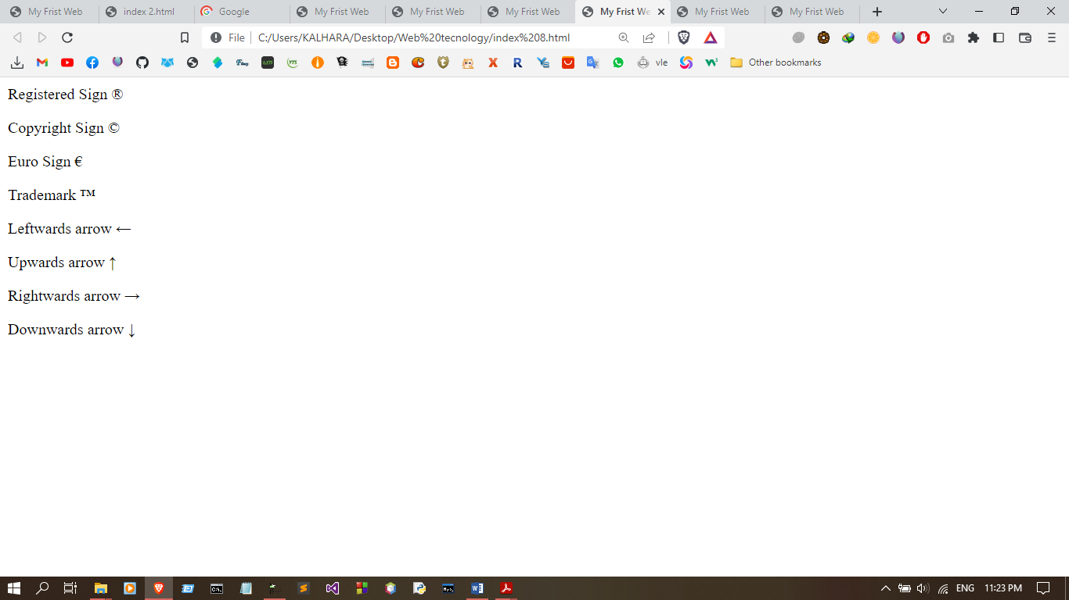

Exercise:
Create a following paragraph in html using basic html tags.
Task:
• Print the paragraph using paragraph tag.
• Underlined words should be link with a website. (any website like google.com)
• Highlighted words can be any color.
• Highlighted words should be italic format.
• Other bolded, superscript and subscript letters should be like the same as the paragraph.

Superscript and Subscript  A subscript (like H2O) or superscript (like x2) is a character (such as a number or letter) that is set slightly below or above the normal line of type, respectively. It is usually smaller than the rest of the text. Subscripts appear at or below the baseline, while superscripts are above. Subscripts and superscripts are perhaps most often used in formulas, mathematical expressions, and specifications of chemical compounds and isotopes, but have many other uses as well.
<html>
<head>
<title>My Frist Web </title>
</head>
<body>
<p>
<b>Superscript</b>and <b>Subscript</b> &#10108; A <b>subscript</b> (like H<sub>2</sub>O)
or <b>superscript</b> (like x<sup>2</sup>) is a character (such<br>as a number or letter)
that is set slightly below or above the normal line of type, respectively. It is<br>usually
smaller than the rest of the text. Subscripts appear at or below the <mark><i>baseline</i></mark>
, while<br>superscripts are above. Subscripts and superscripts are perhaps most often used in
<mark><i>formulas</i></mark>,<br>mathematical <mark><i>expressions</i></mark>, and specifications
of <mark><i>chemical compounds</i></mark> and <mark><i>isotopes</i></mark>, but have<br>
many other uses as well.
</p>
</body>

</html>

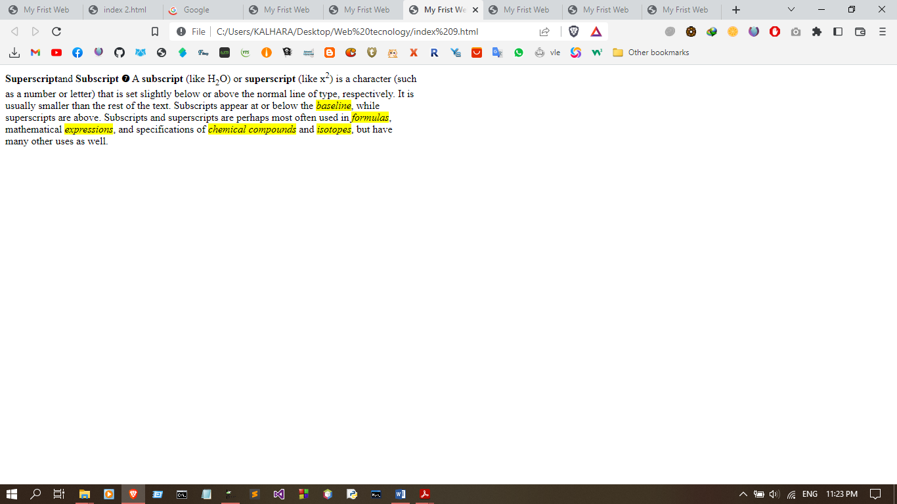
Output :

Discussion:

